Maximizing Sales and optimizing Services of a Financial cum Service-Based Firm
Final report for the BDM capstone Project

Submitted by
Name: Debjit Mondal
Roll number: 23f2004618
Email: 23f2004618@ds.study.iitm.ac.in



IContents
- Executive Summary 2
- Detailed Explanation of Analysis Process/Method
  - Data preprocessing for analysis 3
  - New Investment and redemption trend 3
  - Asset Under Management (AUM) trend analysis 3
  - Risk assessment of clients 4
  - Categorizing clients into different risk categories 5
  - Categorizing mutual funds into different risk categories 5
  - Categorizing clients’ risk exposure in existing investment 6
  - Identifying Top-Performing Mutual Funds Within Risk Categories of
different time frames 7
- Results and findings

New Investment and redemption trends 7

AUM trends 8

Risk assessment of clients and categorization of clients 9

Categorizing mutual funds into different risk categories 10

Categorizing clients’ risk exposure in existing investment 11

Identifying Top-Performing Mutual Funds Within Risk Categories of

different timeframes 12
- Interpretation of Results and Recommendation

Interpretation of Results 18
  - Recommendation 20
- Related links 21

Executive Summary
Unique Enterprise, founded in 2019, is a financial and service-based firm primarily focused on mutual fund sales, with additional offerings like insurance, ITR filing, money transfers, and ticket bookings. Despite its diversified services and emphasis on customer satisfaction, the firm faces challenges in its mutual fund segment due to an unstructured sales approach, leading to inconsistent AUM growth. It also struggles to align investments with clients’ risk profiles, affecting trust and satisfaction. Growing competition from digital platforms offering personalized recommendations has further impacted client retention. Although the firm collects valuable customer data, it remains underutilized for evaluating key performance metrics, limiting strategic decision-making.
As per the data provided by the business for the period between Q1-2022 and Q1-2025, Unique Enterprise exhibited highly inconsistent mutual fund activity. The average sale per transaction was Rs. 3,412.89, with a wide range from Rs. 100 to Rs. 5,99,970 and a high standard deviation of Rs. 23,045.07. On average, 124.74 units were sold per transaction, varying between 0.019 and 45,349.21 units. Redemptions showed similar irregularity, with an average of 513.50 units and Rs. 24,506.51 withdrawn per transaction, ranging up to 19,999 units and Rs. 6,67,719.30, with standard deviations of 2,080.10 units and Rs. 77,371.85 respectively.
To address these inconsistencies, the project focused on streamlining the mutual fund advisory process through data-driven strategies. Quarterly analyses of investment and redemption trends were conducted, and AUM movement was tracked to get gainful insights. Mutual funds were categorized into risk levels using return volatility and K-Means clustering to better align offerings with client risk profiles. As part of this process, a risk assessment form was created in consultation with the business owner to collect information on clients' financial goals, investment horizons, and risk tolerance. Responses were collected and used to assign clients to appropriate risk categories. Furthermore, top-performing funds within each risk segment were ranked to support personalized investment recommendations. This structured and data-driven approach may improve portfolio suitability, enhance client satisfaction, and contribute to stronger revenue performance.
After the analysis it is revealed that two special campaigns that had been organised by the business boosted investor interest and fund inflows, though large redemptions by a few clients caused AUM fluctuations. Many client portfolios were found misaligned with their risk profiles, highlighting the need for proper risk-based advisory. Long-term data showed high-risk equity funds delivered strong returns over time. Aligning portfolios with risk assessments, maintaining regular client engagement, and using data effectively are key to improving satisfaction, retention, and profitability. Implementing these strategies will help the business grow AUM, enhance mutual fund sales, and increase overall profits.

Detailed Explanation of Analysis Process/Method

Data Preprocessing for analysis:
Transaction records were organized into separate Excel files for purchases and redemptions to facilitate detailed analysis. Additionally, historical Net Asset Value (NAV) data originally provided by Unique Enterprise in .DOCX format was converted to .XLSX and consolidated into a single Excel file. To estimate the current Assets Under Management (AUM), units held as of February 28, 2025, were valued using NAV data from Q1-2025. It was assumed that no transactions occurred after February 28, as no further transaction records or NAV data beyond that date were available.

New Investment and redemption trend:
Tracking new investments and redemptions is crucial for evaluating the historical performance of the business in the mutual fund sale category.
By utilizing the spreadsheet’s Pivot Table feature and grouping data by quarters, analyzed the inflow (new investments) and outflow (redemptions) over different time frames. This quarterly categorization provides a comprehensive overview of sales performance trends in mutual funds, helping identify growth patterns, seasonal behavior of a client.

Asset Under Management (AUM) trend analysis:
The business generates revenue from mutual fund sales primarily through a commission-based model, which is directly linked to the Assets Under Management (AUM). As the AUM grows, so does the earning potential of the business, making the scale and retention of investments critical to long-term profitability. The business did not disclose its detailed commission structure due to its partnering agency’s policy, but indicated that the approximate profit margin stands at 0.5% of the total AUM managed annually. This implies that any increase in AUM, whether through new investments or performance of retained assets, contributes proportionally to the firm's revenue from the mutual fund segment.
Understanding the current trend of Assets Under Management (AUM) is essential to assess the business’s earnings from the mutual fund segment, as its profit is directly linked to the AUM it manages. To track AUM across different timeframes, both historical NAV data and transaction records were used. By calculating the number of units held in each mutual fund and applying the respective NAVs at specific dates, the AUM was derived for each period. This method provided a clear view of inflows, outflows, and net asset value changes, allowing for the identification of AUM trends over time. These trends provide valuable insights into the scale of assets managed and the potential profit generated through commissions.

Risk assessment of clients:
Risk assessment plays a vital role in mutual fund investments, as these involve the possibility of financial loss alongside potential gains. It helps determine how much risk a client is both willing and able to take based on their financial situation, investment goals, and risk tolerance.New investors often struggle to understand their own risk capacity, making proper risk assessment a crucial first step in the advisory process. For existing clients, regular reassessment is equally important, as their financial priorities and life circumstances may evolve over time.
However, online mutual fund platforms pose a competitive challenge by offering built-in tools that allow users to select funds based on predefined risk categories. This feature increases client convenience and can lead to potential loss of clients for traditional businesses like Unique Enterprise.
To address this, with the help of the owner of the business, developed a risk assessment form, distributed through both Google Forms and printed copies, and collected responses from both the medium (for printed copies, responses consolidated into a response sheet manually). Each response was assigned a score based on a scale created in consultation with the business owner.
Risk assessment form (Google form):
https://docs.google.com/forms/d/e/1FAIpQLSdKv2isTiOg5-EHrDzbSmVjnnHA83W6i9IzILSzNtcnxmjNfw/viewform?usp=sharing&ouid=101641503971684363920
Risk assessment form (Hard Copy):
https://drive.google.com/file/d/12rx2cLUW3BFpvOkEOHi33EAmdNXjOlqJ/view?usp=drive_link
Formula used for risk assessment:
https://drive.google.com/file/d/1jk9qblpoVV_owNsLwX8ts--c7DsvYwWG/view?usp=drive_link

Categorizing clients into different risk categories:
Based on the scores obtained from the risk assessment form, clients are classified into distinct risk categories to guide suitable mutual fund recommendations. The scoring system helps align investment options with each client's risk tolerance. The classification is as follows (calculated with consultation of the business owner):
- High Risk: Risk Score > 67
- Medium Risk: Risk Score between 51 and 67
- Low Risk: Risk Score ≤ 50
This categorization helps the business to personalize investment strategies, recommend appropriate mutual fund products, and ensure that client portfolios are aligned with their financial goals and risk appetite.

Categorizing mutual funds into different risk categories:
Mutual funds display varying return patterns over time ranging from high gains to moderate or even negative returns. To objectively assess the risk level of each fund, mutual funds were categorized into high, moderate, and low risk segments based on their return volatility.
Using historical return data provided by the business, the standard deviation of returns was calculated over different timeframes. This served as the input for a K-Means clustering algorithm (Using the scikit-learn library), which grouped the mutual funds into distinct risk categories:
- High Risk: High return variability over time
- Moderate Risk: Moderate variability over time
- Low Risk: Stable returns with low fluctuation over time
The analysis was performed using Google Colab, and the categorized mutual fund data was exported and downloaded in XLSX format for further analysis. This categorization provides a data-driven framework to align mutual fund offerings with the appropriate client risk profiles identified through risk assessment.

Categorizing clients’ risk exposure in existing investment:
To understand the current risk exposure of existing clients, their investment patterns were analyzed using transaction data provided by the business. Spreadsheet functions were used to identify the distribution of each client's current investments across various mutual funds.
Using the mutual fund risk categories derived through K-Means clustering in the previous step (aggressive, moderate, and low risk), each client’s portfolio was evaluated. Clients were then categorized based on the percentage of their total investment allocated to each risk category:
- Clients with a majority of investment in high-risk funds were classified as Aggressive Risk Exposure. (More than 50% in high risk funds)
- Those with balanced exposure were labeled Moderate Risk Exposure. (More than 50% in medium risk funds)
- Clients investing mainly in low-risk funds were categorized as Low Risk Exposure.(More than 50% in low risk funds)
This classification provides valuable insights into whether clients are currently aligned with their stated risk tolerance and helps identify those who may need portfolio rebalancing or updated financial advice.

Identifying Top-Performing Mutual Funds Within Risk Categories of different time frames:
After categorizing mutual funds into high, moderate, and low risk groups using the K-Means algorithm based on the standard deviation of historical returns, the next step involved ranking the funds within each risk category of different time frames.
By analyzing the average returns over selected timeframes on the downloaded xlsx file, the mutual funds in each category were aligned in descending order of performance. This helped in identifying the top 10 performing mutual funds within each risk group of different time frames which the business can use to suggest new investment according to the client’s needs.

Results and findings:

New Investment and redemption trends:
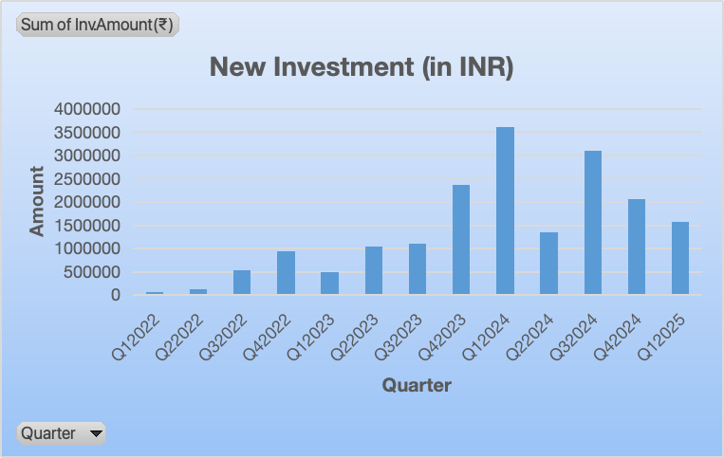
Fig 3.1.1: New Investment trend
The chart (Fig: 3.1.1) shows how new investments in mutual funds changed from Q1-2022 to Q1-2025. Investments grew slowly at first, from Q3-2022 to Q3-2023. There was a big jump in Q4-2023, and the highest investment happened in Q1-2024, with nearly Rs. 4 crore invested. This was mainly because of a campaign organized by the business during a corporate function of a mining company in Q1-2024. Another campaign was held in Q3-2024 at corporate training college, which also helped increase investment that quarter. After Q1-2024, investments went up and down dropping in Q2-2024, rising again in Q3-2024 due to the second campaign, and then falling in Q4-2024 and Q1-2025. Even with these ups and downs, the investment levels stayed higher than before Q4-2023. These results show that such campaigns are effective and can be used again to attract more investors.
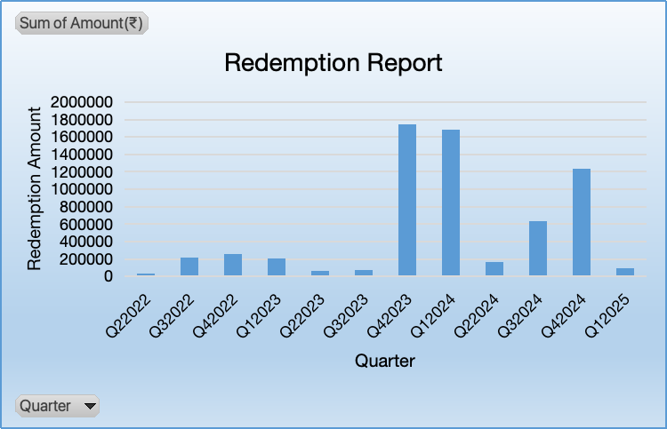
Fig 3.1.2: Redemption trends
The Redemption Report chart (Fig:3.1.2) shows the amount withdrawn from mutual fund investments each quarter from Q2-2022 to Q1-2025. In the early quarters, redemption amounts were relatively low and stable. A major spike occurred in Q4-2023 and Q1-2024, where redemption values sharply increased, crossing Rs.1.8 crore in both quarters. After that, redemptions dropped in Q2-2024, but rose again in Q3 and Q4-2024, before falling back to a lower level in Q1-2025. This surge was primarily caused by two investors redeeming a substantial amount. Despite these fluctuations, the redemptions remained significantly higher post-2023 compared to earlier periods, highlighting the need for closer monitoring of investor behavior and redemption triggers.

AUM trends:
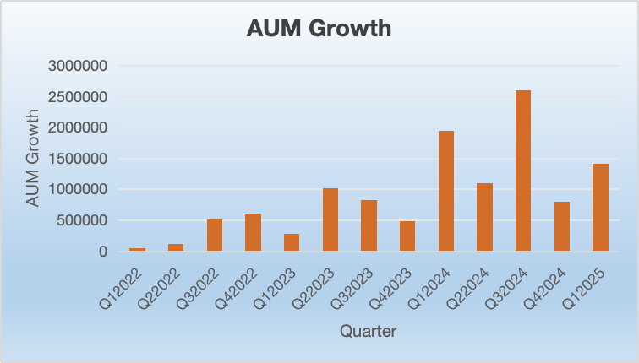
Fig 3.2: AUM trends
Starting from Q3-2022, a gradual increase in AUM growth became visible(Fig:3.2), which continued steadily through to Q3-2023. This suggests a phase of consistent investment activity, possibly driven by growing investor confidence and awareness.
A sharp rise was observed in Q1-2024, marking a significant improvement in AUM growth. The upward trend peaked in Q4-2024, with the highest growth in the entire period crossing Rs. 25 lakhs. This peak aligns with the timing of major investment campaigns conducted during corporate events and training college sessions, indicating that targeted outreach efforts had a direct and positive impact on asset growth.
Though AUM growth slightly declined in Q1-2025 compared to the previous quarter, it remained much higher than the levels recorded before Q4-2023. This suggests that, despite some quarterly fluctuations, the base of managed assets has expanded significantly in recent times.
Since profits from mutual funds are commission-based, higher AUM leads directly to increased earnings.
Overall, the AUM growth trend shows a strong positive shift in investor engagement and fund inflows after 2023. This clearly shows that AUM growth drives higher commission-based income, making it vital to sustain investor engagement and fund inflows through regular campaigns.

Risk assessment of clients and categorization of clients:
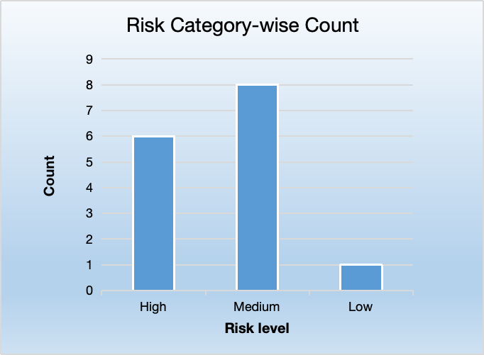
Fig 3.3: Risk category count
Although the business has over 160 clients, only 15 responses were received from the risk assessment surveys (till 02.06.2025). While the current response rate is low, the results still offer useful insights
The analysis shows that most investors prefer a medium level of risk. Out of 15(Fifteen) people, 8(Eight) investors (more than half) fall into the Medium risk category. This means they are comfortable with some risk for a balanced return. 6(Six) investors are in the High risk category, showing they are ready to take more risk for the chance of higher returns. One person has a very high risk score, showing strong confidence in taking risks. Only 1(One) investor falls in the Low risk category.
In the future, as more clients complete the survey, the business can better classify all investors and offer more suitable investment choices. It will also help in guiding new investors by understanding their risk profile early on and recommending the right products from the start, leading to more informed and confident investment decisions.

Categorizing mutual funds into different risk categories:
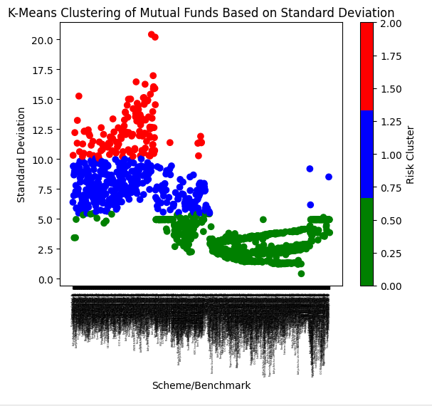
Fig 3.4.1: Categorizing all funds using K-means algorithms (Red dot-> high risk, blue dot-> Moderate risk, green-> Low)
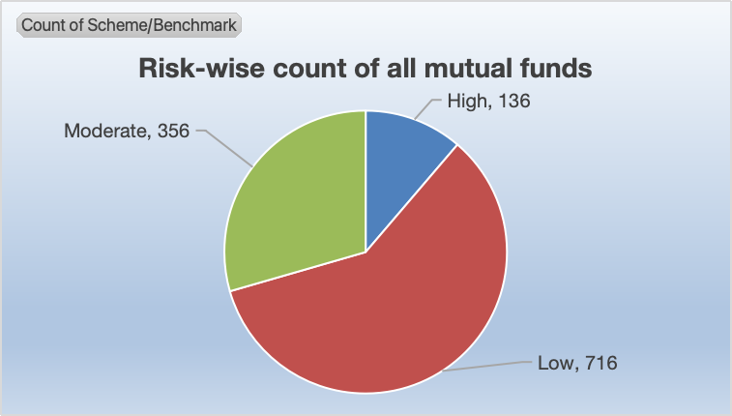
Fig 3.4.2: Risk-wise count of all mutual funds
After applying the K-means clustering algorithm using standard deviation-based grouping, the mutual fund schemes were divided into three main risk categories: Low, Moderate, and High. The clustering showed that most mutual funds (716 schemes) fall under the Low-risk category, followed by 356 Moderate-risk and only 136 High-risk schemes. This means the majority of available mutual funds are stable with less price fluctuation (low standard deviation), making them suitable for conservative investors. The clustering helped to clearly group funds based on actual risk behavior rather than preset labels, offering better clarity for clients when matching their personal risk capacity with the right set of funds.

Categorizing clients’ risk exposure in existing investment:
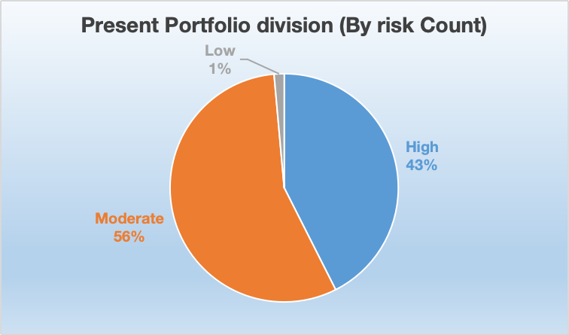
Fig 3.5.1: Overall AUM division (Riskwise)
The current portfolio distribution shows that about 43% of client investments are in high-risk funds, around 56% are in moderate-risk funds, and only about 1% is in low-risk funds.
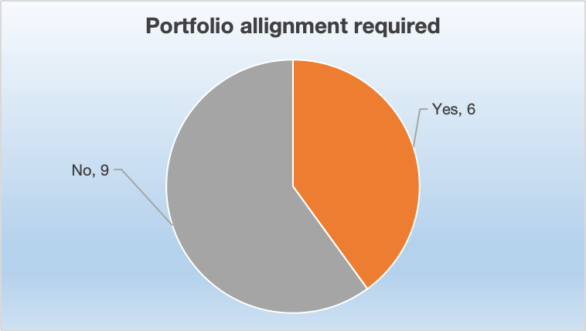
Fig 3.5.2: Portfolio alignment required
Out of the 15 clients who took the risk assessment survey, 6 were found to have investments that did not match their actual risk profiles, indicating a need for portfolio realignment to better suit their financial goals and comfort with risk.

Identifying Top-Performing Mutual Funds Within Risk Categories of different timeframes:

6-Month Performance:
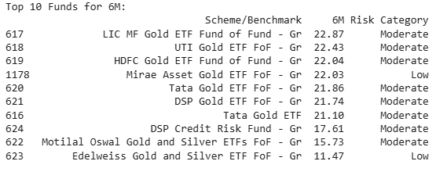
Fig 3.6.1.1: Top 10 performing funds of last 6 month
In the past 6 months, the top-performing mutual funds have mostly been Gold ETF Funds, showing excellent short-term growth. The best performer was the LIC MF Gold ETF Fund of Fund, delivering a return of 22.87%. Most of these funds fall under the Moderate risk category, with two funds Mirae Asset and Edelweiss categorized as Low risk. This trend shows that gold funds have done well in the short run, making them a good choice for investors looking for moderate-risk options with quick returns.

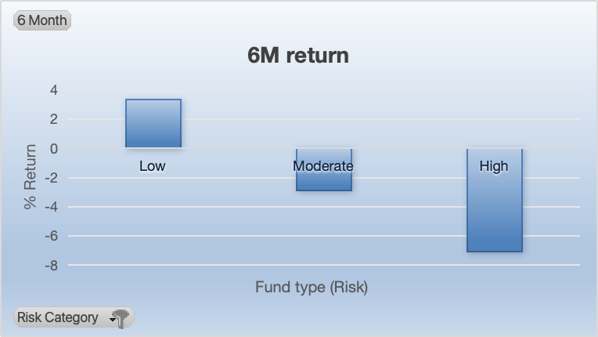
Fig 3.6.1.2: Riskwise average return of all funds (6 Months)
The 6-month return chart (Fig: 3.6.1.2) shows how different types of mutual funds performed based on their risk level. Low-risk funds did the best, giving a return of about 3%, which means they grew a little and stayed stable. Moderate-risk funds gave a small negative return, so they lost a little money. High-risk funds performed the worst, with a return of nearly -7%, meaning they lost the most. This means that in the last six months, safer investments did better, while riskier ones did not perform well.

1-Year Performance:
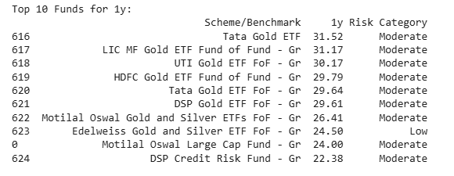
Fig: 3.6.2.1: Top 10 performing funds of last 1 year
Over the last 1 year, Gold ETFs have again taken the lead, with Tata Gold ETF topping the chart at 31.52% return. Most of the top funds in this period are in the Moderate risk category, while Edelweiss Gold and Silver ETF remains in the Low risk group. One interesting entry is the Motilal Oswal Large Cap Fund, which offered 24.00% returns, showing that some equity-based funds also performed strongly. This highlights that gold remained a reliable asset for moderate-risk investors over the year.
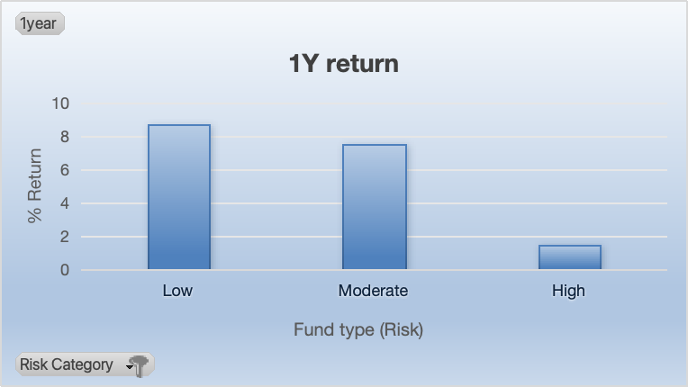
Fig: 3.6.2.2: Riskwise average return of all funds (1 Year)
The 1-year return chart (Fig: 3.6.2.2) shows how mutual funds with different risk levels have performed over the past year. Low-risk funds did the best, giving a return of about 8.5%, which means they grew well and stayed safe. Moderate-risk funds also gave good results, with a return of around 7.5%, which is good for people who can take a little risk. High-risk funds, however, gave a small return of only 1.5%, which is not very good considering the high risk involved. This means that safer and balanced investments worked better than risky ones in the last year.

5-Year Performance:
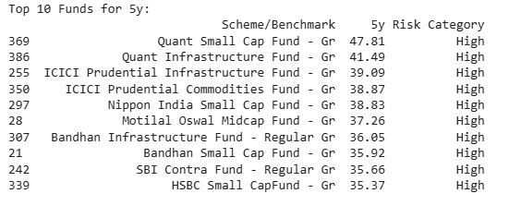
Fig: 3.6.3.1: Top 10 performing funds of last 5 years
When looking at the 5-year period, the top 10 funds are entirely equity-based, with Quant Small Cap Fund leading at a return of 47.81%. Other top performers include funds focusing on infrastructure and commodities. All these funds are marked as High risk, reflecting their exposure to market volatility. The strong performance of small-cap and sector-specific equity funds over five years shows they are best suited for investors with a higher risk appetite aiming for long-term capital growth
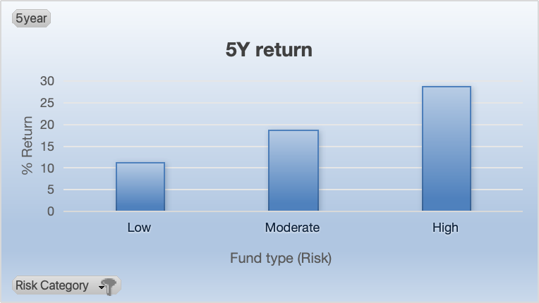
Fig: 3.6.3.2: Riskwise average return of all funds (5 Years)
The 5-year return chart (Fig: 3.6.3.2) shows how mutual funds with different risk levels have performed over the last five years. High-risk funds gave the highest return, around 30%, meaning they grew the most but also came with more risk. Moderate-risk funds did well too, with a return of about 19%, giving a good mix of safety and growth. Low-risk funds gave the lowest return, around 11%, but they were safer and more stable. This means that over a long time, taking more risk gave better results, while safer funds grew slowly but steadily.

10-Year Performance:
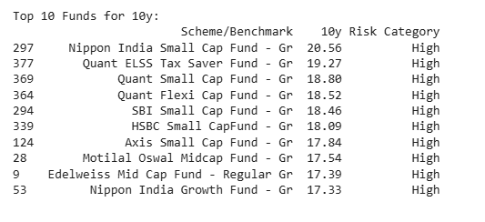
Fig: 3.6.4.1: Top 10 performing funds of last 10 years
Over the past 10 years, Nippon India Small Cap Fund has delivered the highest return of 20.56%. All top funds in this group fall under the High risk category and mostly include small-cap and mid-cap equity funds. This shows that high-risk funds have consistently provided better returns over a decade. For investors who are patient and can handle short-term fluctuations, these funds offer strong compounding benefits over the long term.
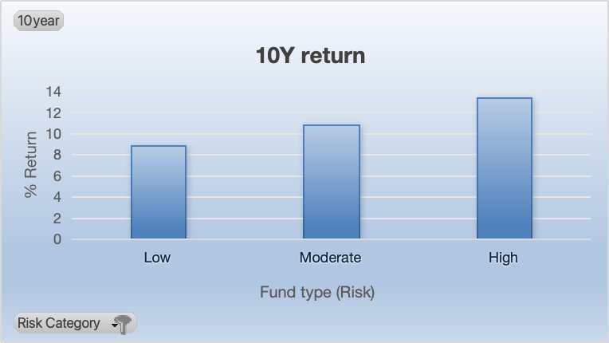
Fig: 3.6.4.2: Riskwise average return of all funds (10 Years)
The 10-year return chart shows how mutual funds have performed over a long period across different risk levels. High-risk funds gave the highest return of about 13.5%, showing strong growth for those who were ready to take more risk. Moderate-risk funds gave a return of around 11%, offering a good mix of safety and return. Low-risk funds gave the lowest return, about 9%, but they were more stable and less risky. This means that over 10 years, all types of funds grew well, but higher-risk funds gave the best returns for patient investors.

15-Year Performance:
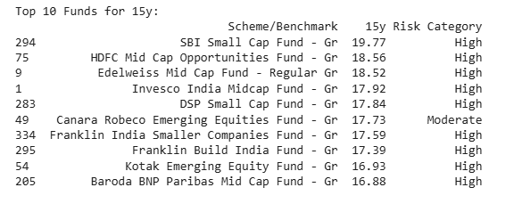
Fig: 3.6.5.1: Top 10 performing funds of last 15 years
In the very long term, the SBI Small Cap Fund led with an impressive return of 19.77%. Out of the top 10 funds, 9 are classified as High risk, and only one Canara Robeco Emerging Equities Fund falls into the Moderate risk category. These results clearly show that high-risk small-cap and mid-cap equity funds have delivered the highest returns over 15 years. Long-term investors who can tolerate risk and remain invested are likely to benefit the most from such funds.
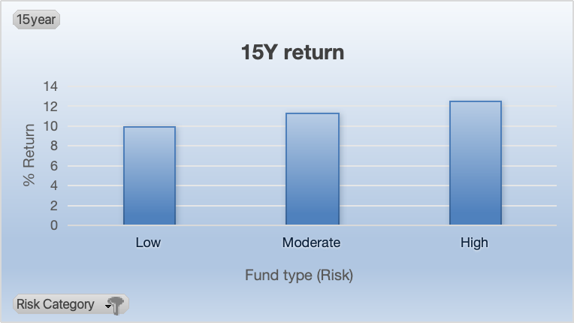
Fig: 3.6.5.2: Riskwise average return of all funds (15 Years)
The 15-year return chart shows how mutual funds performed over a long period based on their risk level. High-risk funds gave the best return of about 12.5%, showing that they can grow well over time if investors are ready to take more risk. Moderate-risk funds also did well, with returns of around 11%, offering a good balance between safety and growth. Low-risk funds gave a return of about 9.5%, which is lower but came with more stability. This means that over 15 years, all types of funds gave good results, but higher-risk funds gave slightly better growth in the long run.

Average returns of top 10 funds of different timeframes:
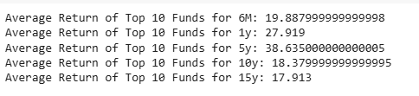
Fig: 3.6.6:Average returns of top 10 funds
The top 10 mutual funds delivered the highest average return over 5 years (38.64%), followed by strong performance in 1 year (27.92%) and 6 months (19.89%). Long-term returns over 10 and 15 years remained stable at around 18.38% and 17.91%, mainly driven by high-risk equity funds.

Interpretation of Results and Recommendation

Interpretation of Results

New Investment Trends
      - From Q3-2022 to Q3-2023, mutual fund investments showed a slow but steady increase, indicating gradual investor engagement.
      - A significant rise occurred in Q4-2023, peaking in Q1-2024 with investments touching nearly Rs. 4 crore. This growth directly correlates with a campaign organized at a mining company's corporate event.
      - A second campaign in Q3-2024 at a corporate training college also contributed to another spike in investment, showing a positive link between outreach efforts and fund inflows.
      - Despite fluctuations after Q1-2024, investment levels remained higher than pre-campaign periods, confirming the long-term impact of strategic investor engagement.

Redemption Trends
      - Redemption volumes remained relatively low and consistent until Q3-2023, suggesting stability in investor behavior.
      - A sharp surge occurred in Q4-2023 and Q1-2024, with redemptions crossing Rs. 1.8 crore in both quarters.
      - This spike was primarily due to large withdrawals by two major investors, highlighting the sensitivity of overall redemption trends to a small number of high-value clients.
      - Redemptions declined in Q2-2024, rose slightly again in Q3 and Q4-2024, and fell in Q1-2025, but overall levels post-2023 were higher than earlier, indicating the need for improved retention and monitoring mechanisms.

AUM Trends
      - AUM growth was gradual and stable from Q3-2022 to Q3-2023, suggesting increasing trust in mutual funds.
      - A sharp spike in Q1-2024 and a peak in Q4-2024 were seen, driven by successful campaigns. This indicates that structured outreach can directly grow AUM.
      - Although there was a small decline in Q1-2025, AUM levels remained significantly higher than pre-Q4-2023, reflecting sustained investor confidence.
      - Since mutual fund profits are commission-based, higher AUM translates into higher income, underlining the financial benefit of maintaining fund size growth.

Client Risk Assessment
      - Only 15 clients completed the risk assessment survey, despite the business having over 160 clients.
      - The survey showed that 8 out of 15 investors prefer a medium level of risk, followed by 6 who fall into the high-risk category, and only 1 in the low-risk segments.
      - While limited, this data indicates that the majority of participating clients are comfortable with moderate risk, favoring balanced investment options.

Mutual Fund Risk Categorization (via K-means)
      - The K-means algorithm was used to classify mutual funds based on standard deviation, leading to three risk categories: Low, Moderate, and High.
      - From all the mutual fund schemes that the business offers, 716 funds fell under the low-risk group, 356 under moderate-risk, and 136 under high-risk.
      - This shows that the majority of schemes are low-risk, suitable for conservative investors, and that actual risk categorization offers more reliable client guidance than default fund labels.

AUM Risk Distribution
      - The total AUM is majorly allocated to medium-risk schemes (52.08%), suggesting a balanced investment strategy by most clients.
      - High-risk funds account for 46.14% of AUM, indicating significant exposure to volatile assets, likely from a smaller group of aggressive investors.
      - Only 1.8% of AUM lies in low-risk funds, showing minimal conservative investment adoption.

Mutual Fund Performance by Timeframes
      - In the last 6 months, Gold ETFs performed the best, with most of the top 10 funds in the moderate-risk category.
      - Over 1 year, Gold ETFs continued to dominate, and one equity fund also delivered strong returns, showing opportunities for moderate-risk investors.
      - ​​In the short term, low-risk investments offered better protection and returns than aggressive ones.
      - For the 5-year period, all top funds were equity-based and high-risk, with strong returns led by small-cap and infrastructure-oriented funds.
      - Over a 5-year horizon, higher-risk funds begin to show their potential, but moderate-risk options also provide strong and more balanced growth.
      - Over 10 and 15 years, high-risk equity funds dominated returns, affirming their long-term strength for investors with a higher risk appetite.
      - Over longer durations, all risk categories gave good returns, but high-risk funds provided the highest growth, justifying the risk over time.
      - The average return across timeframes shows peak performance in the 5-year range (38.64%), followed by 1-year and 6-month returns. Long-term returns (nearly 18%) remained strong but relatively stable, underlining the power of compounding.

Recommendation
    - Conduct regular campaigns at different institutions as past campaigns significantly increased fund inflows.
    - Track high-value investors closely to manage redemption risk.
    - Make risk assessment during new investments of new clients and follow up with existing clients to ensure accurate investment guidance.
    - Identify clients whose investments don't match their risk tolerance and suggest rebalancing.
    - Promote long term investments, especially in high-risk equity funds for wealth creation through compounding.
    - Suggest low-risk funds for short-term needs, high-risk funds for long-term growth, and moderate-risk funds for medium-term goals to give clients a good balance of safety and returns.
    - Diversify across risk types depending on the client’s time horizon and risk appetite to minimize overall portfolio risk and achieve balanced returns.
    - Since market trends can change, the business should regularly monitor clients’ portfolios to ensure they remain aligned with their goals and risk profiles.

Related links:
    - Photos and video of the business: https://drive.google.com/drive/folders/1sZa46KCoMv-6xQbrbY0VoYzp7k5LkAal?usp=drive_link
    - Raw data: https://drive.google.com/drive/folders/1gn_29tHUCDGZeclAys0WFE611qamgmVb?usp=drive_link
    - Data after cleaning and processing: https://drive.google.com/drive/folders/19g_hz3zwFucYyKiVQQv7y3m_t-dGra4F?usp=drive_link
    - Risk assessment survey: https://drive.google.com/drive/folders/1ZtXicvfZAYBeNhtJt0Buo_9NPoggoL2P?usp=drive_link
    - Analysis files: https://drive.google.com/drive/folders/1bIBxPDAAGMk_yk3JTWIB0kJuvmeWWRQO?usp=drive_link

